Overall Intent

To introduce babies to the joy of celebration through sensory experiences, music, colour, light, textures, and family/community traditions.
Communication and Language

Listening to festive sounds, nursery rhymes, and celebration stories; early words related to celebrations.
Sing festive and traditional songs (e.g. “Happy Birthday,” Christmas jingles, Diwali rhymes).
Explore sound-making instruments (drums, bells, shakers).
Use simple descriptive words during play (e.g. “bright,” “red,” “sparkly”).
Read short board books about lights, birthdays, and family celebrations.

Physical Development

Fine motor: exploring textures, shaking instruments, mark making.
Gross motor: dancing, movement to music.
Dance and move to music from different festivals.
Explore sensory trays (rice, noodles, tinsel, glitter playdough).

Wave ribbons, shake instruments, or reach for lights.

Crawl or toddle toward light and sound sources.

Personal Social and Emotional Development

Building positive relationships, experiencing shared joy, and learning about kindness and togetherness.
Celebrate birthdays and nursery “special days” together (group singing, blowing bubbles, balloons).
Look at family celebration photos and talk about “my family.”
Participate in small-group sensory activities for Diwali, Christmas, and Autumn/Winter.
Share smiles, claps, and positive reactions during music and light play.

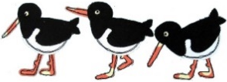
Curriculum Web
Baby Room
Term 2
Festivals and Celebrations

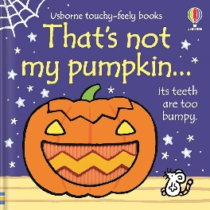
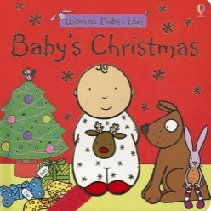
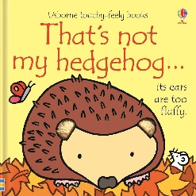
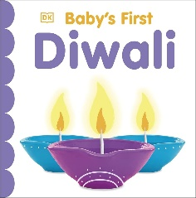
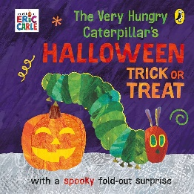
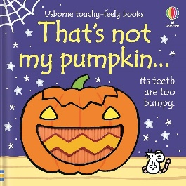
Arts – Craft and Music Opportunities

Music, messy play, art using festive colours and sensory materials.

Create sparkly artwork using foil, glitter, and paint.
Decorate the baby room tree or wall displays.
Make festive sensory bottles with coloured water, glitter, and lights.
Explore musical instruments from different cultures.

