My ADHD
Diagnosis
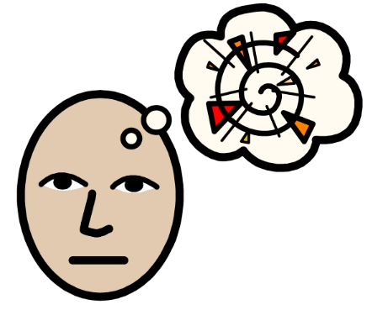

This book belongs to:

ADHD stands for Attention Deficit / Hyperactivity Disorder.
ADHD is a neurological condition. This means it affects how my brain processes (and prioritises) information.
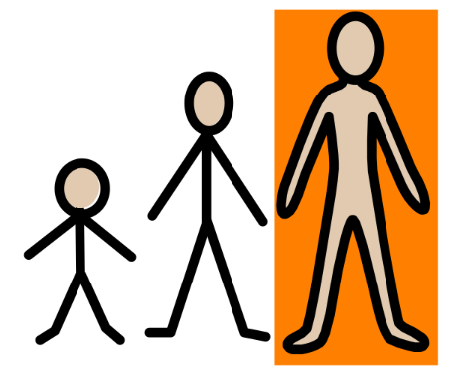

I have been diagnosed with ADHD.

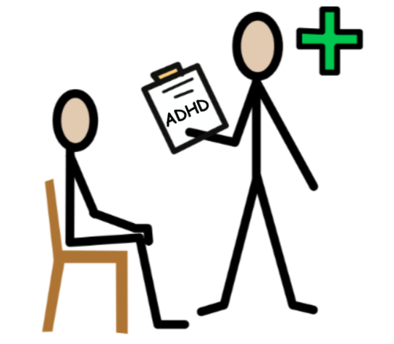

ADHD is a condition I was born with.
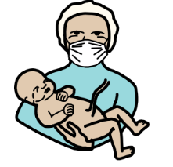

Having ADHD means that my brain works differently, and I may learn differently, to other children my age.
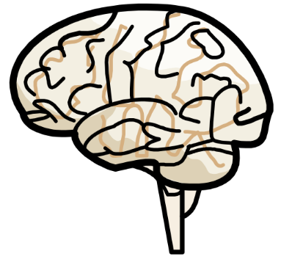
ADHD is not bad; it is just different. My brain is “atypical”.
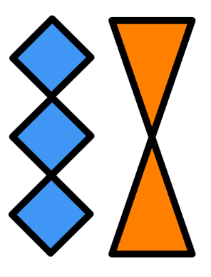

I am not lazy or stupid.
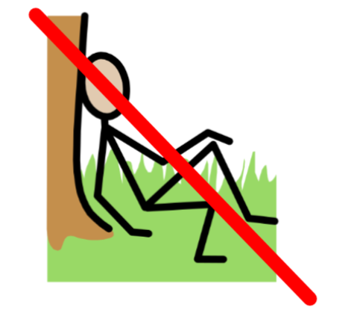

I work hard, and I am as clever as my friends.
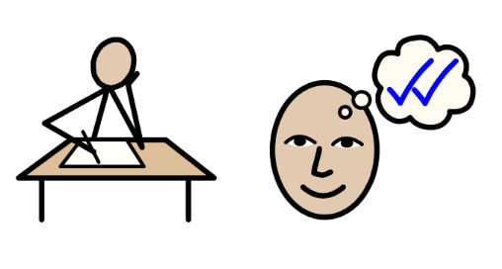

Having ADHD can be like having Super-powers!
Everyone with ADHD is different. Some people can focus really well on the things they are interested in making or doing.
Some people can think, read or write very quickly.
Some of my ADHD Super-powers are:
Sometimes I may need a few tools to help me learn best. This is okay. Some Superheroes need shields, hammers or capes, sometimes, too.
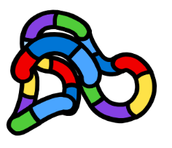 | 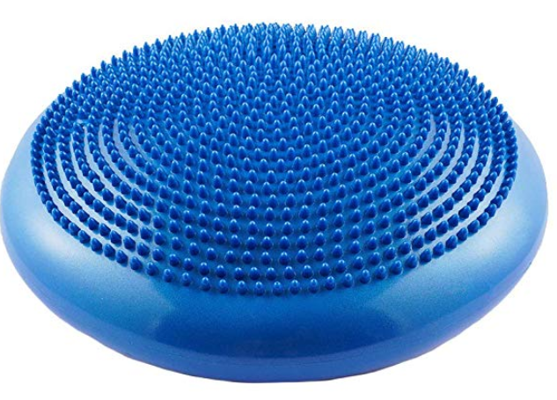
fidget toys | wobble cushion
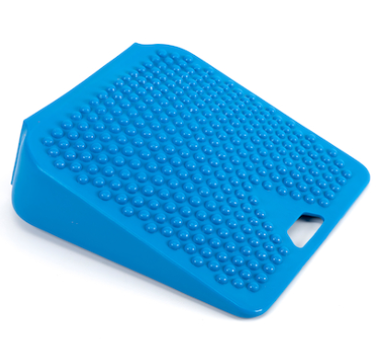 | 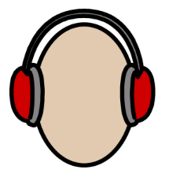
posture cushion | ear defenders
daily dashboard | reminders

ADHD symptoms are usually noticed at an early age, but ADHD is not something I will grow out of.
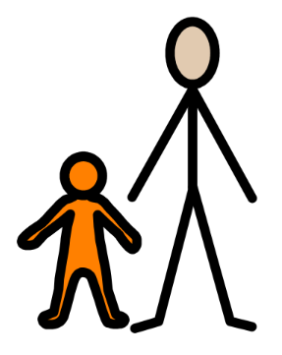
My parents/carers noticed my symptoms when I was ________ years old.
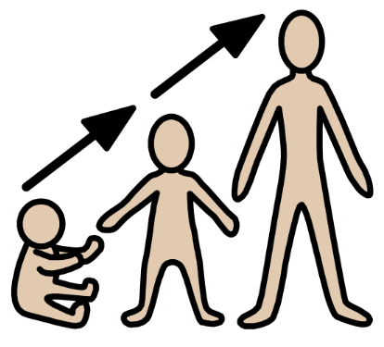
Most cases are diagnosed when children are 6 to 12 years old.
My ADHD symptoms will probably improve as I grow up and learn strategies which work for me.
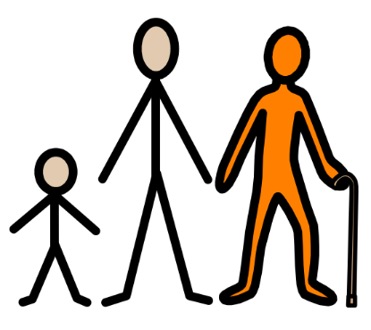
I will always have ADHD, but I will get better at knowing myself and choosing the right tools and strategies to help me be my best self.

Because of the way my ADHD brain works, I may also struggle with:
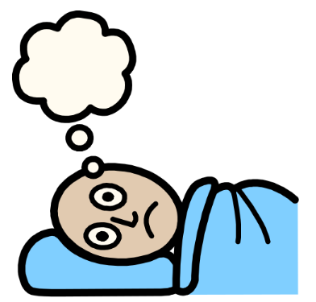 | 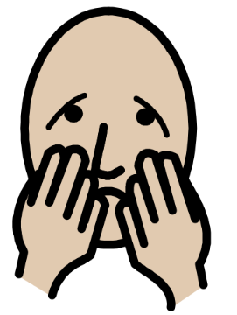
sleep disorder | anxiety disorder
focusing/  remembering | switching between tasks
keeping tidy | being organised
This is okay. I can find ways to help with these things.
There are three main types of ADHD:
Predominantly Inattentive; Predominantly Hyperactive-Impulsive, and
Combined (both inattentive and hyperactive-impulsive).
Inattentive | Combined | Hyperactive-Impulsive

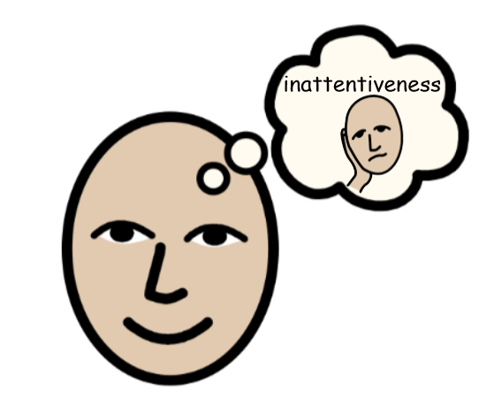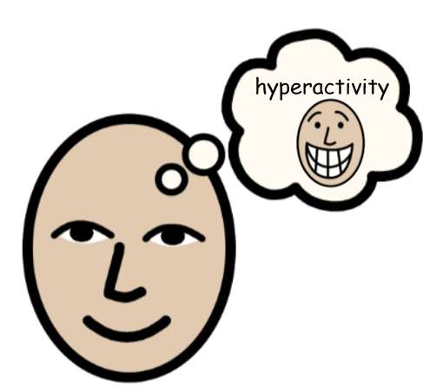

The main signs of inattentiveness are:
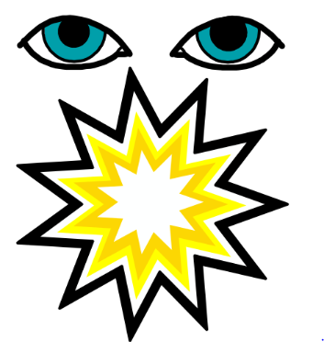 | 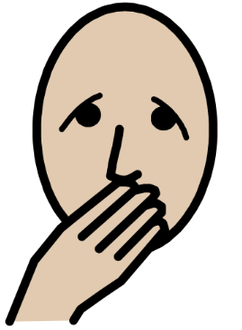
having a short attention span /easily distracted | making careless mistakes
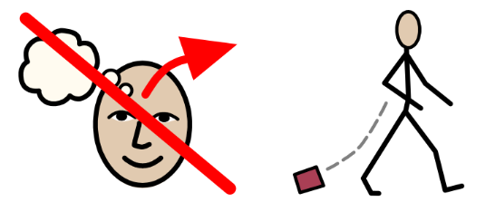 | 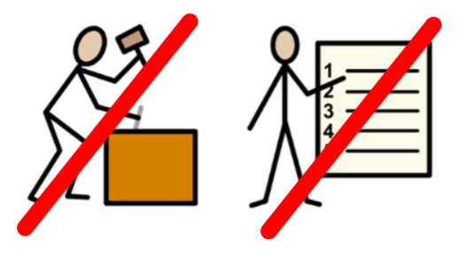
forgetting or losing things | being unable to stick to tasks or carry out instructions
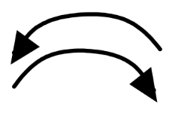 | 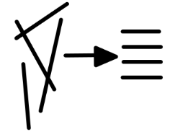
constantly changing activity or task | having difficulty organising tasks.

The main signs of hyperactivity are:

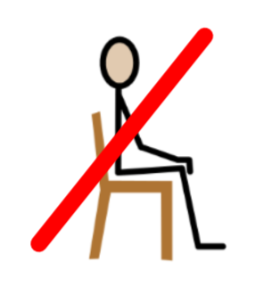 | 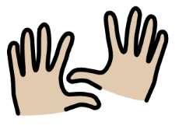 | 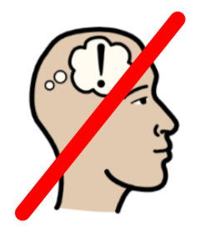
being unable to sit still | constantly fidgeting | trouble concentrating on tasks
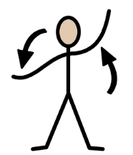 | 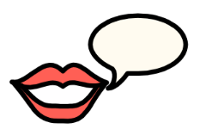 | 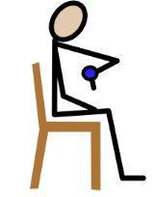
excessive physical movement | excessive talking | inability to wait my turn
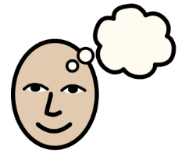 | 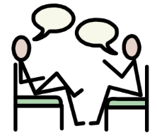 | 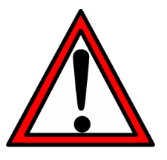
acting without thinking | interrupting conversations | little or no sense of danger

There is no cure for ADHD. It is okay to be different.
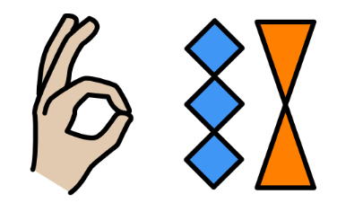
I can work with doctors, therapists and teachers to learn how to play to my strengths and find strategies to help with my challenges.

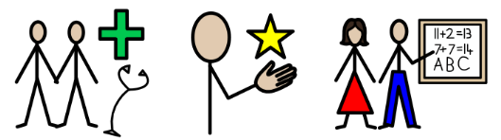

Some people with ADHD can take medicine to help them stay focussed and remember important things.
Some people don’t react well to medicine. This is okay. There are lots of strategies and resources which can also help. 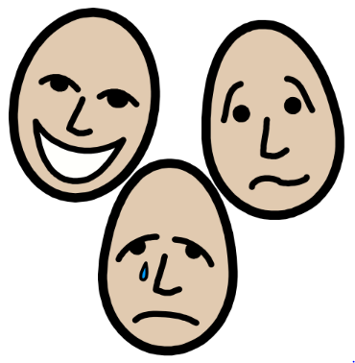
At times, I may have trouble regulating my feelings and emotions. This is okay and is normal for people with ADHD.
I would like people to help me by:
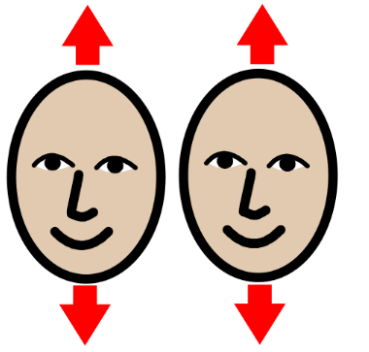 | 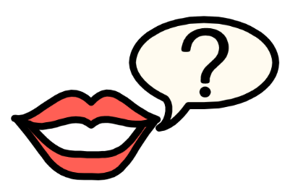
accepting my differences | asking how they can help me
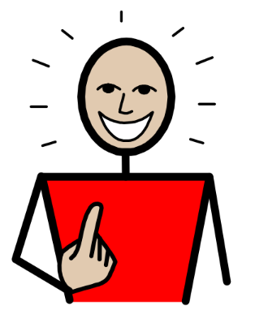 | 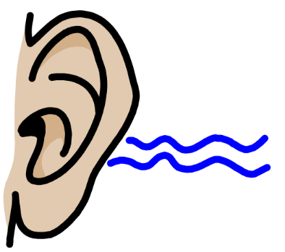
noticing and valuing my strengths | being a good listener
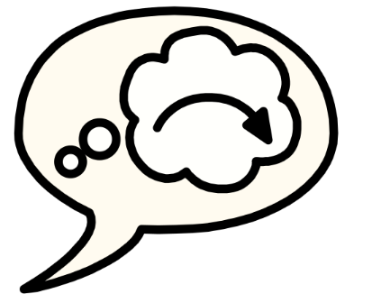 | 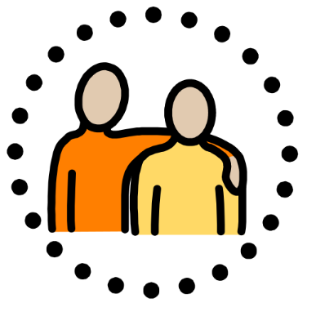
reminding me if I go off-task | helping to keep me safe while I am out and about
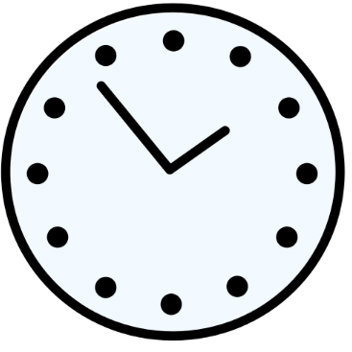 | 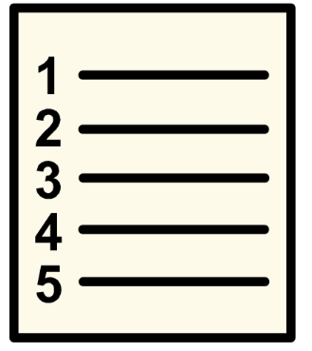
helping me to keep track of time | helping me break down tasks into manageable parts
Having a brain which thinks differently has made lots of people famous and helped the whole world.
All of these people have or had ADHD:
Britney Spears | Michael Jordan | Zooey Deschanel
Michael Phelps | Liv Tyler | Justin Timberlake
J. F. Kennedy | Albert Einstein | Bill Gates
…and many more!
I should always feel proud for being myself.
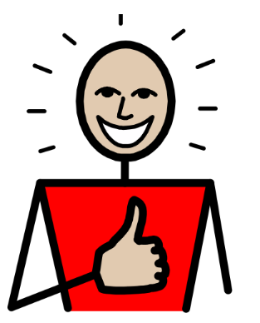

ADHD helps make me ME!

I am amazing! Knowing and understanding myself can help me use all of my strengths and potential to be the best ‘Me’ I can be!

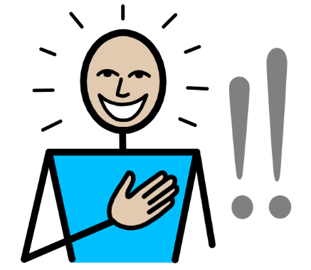

Further information:

Video Links to explain ADHD:
https://www.youtube.com/watch?v=KyOdenFEwnQ
https://childmind.org/story/learn-about-adhd-campaign/
Interesting books about ADHD:
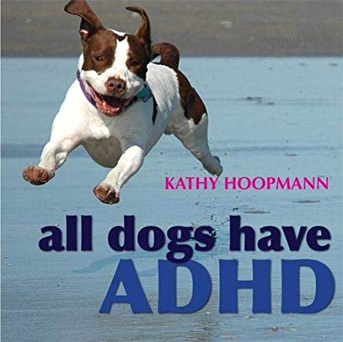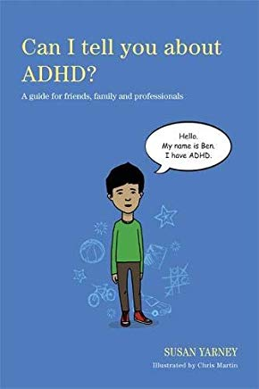
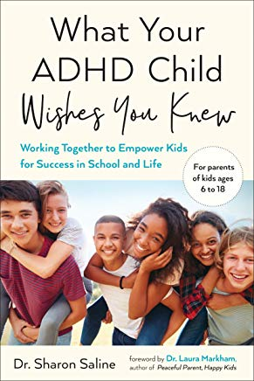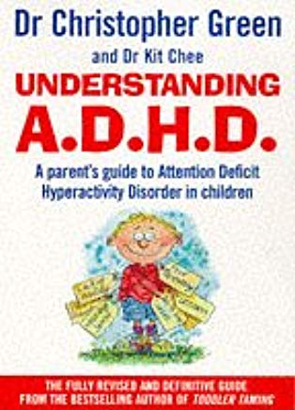

Books with ADHD-friendly strategies:


